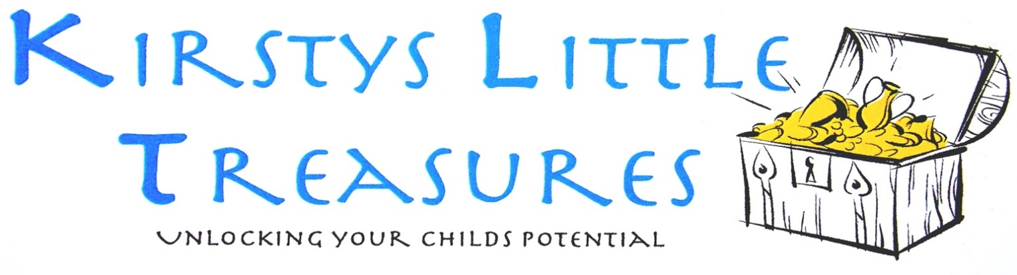

Dear Parent/Carer,

Thank-you for taking the time to enquire about KLT’s and the facilities that we can offer.

My name is Kirsty Toolan and I head KLT’s. I hold a BA Hons in Early Years and have numerous other childcare and management qualifications (available for viewing upon request). I have over 20 years’ experience within childcare; I have worked as a manager, supervisor and a practitioner; I now own KLT’s which opened in January 2014; as such I am well versed in all aspects of childcare and development. In 2024, we opened our second location, Redbrick House, for our under 2s. This is a much more homely environment for the younger children.

We have excellent facilities for children both indoors and outdoors. We have an Ofsted approved setting with a variety of different opportunities and experiences for the children within our care.

KLT’s is pleased to offer a safe haven for your child with an abundance of activities and areas of interest for the children to explore, we pride ourselves in actively promoting enjoyment and development on a daily basis.

As a setting we are open 0730–1800, Mon–Fri, 51 weeks of the year, less bank holidays, Christmas Eve and New Year’s Eve. We are very keen to meet all of your childcare needs, to this end we offer either, full or part time placements as well as term time only (subject to availability).

Enclosed within this pack is more detailed information around hours of operation, costs and holidays. Also included is an Ofsted reference number that you can use to access a copy of our most recent Ofsted Inspection Report.

May I take this opportunity to offer you my personal attention, please do not hesitate in contacting me on the number or e-mail address found within this pack.

I look forward to meeting you soon.

Kind Regards,

Kirsty Toolan
Please visit us on daynurseries.co.uk for lots of parent feedback and reviews

Kirsty Toolan BA Hons EYP
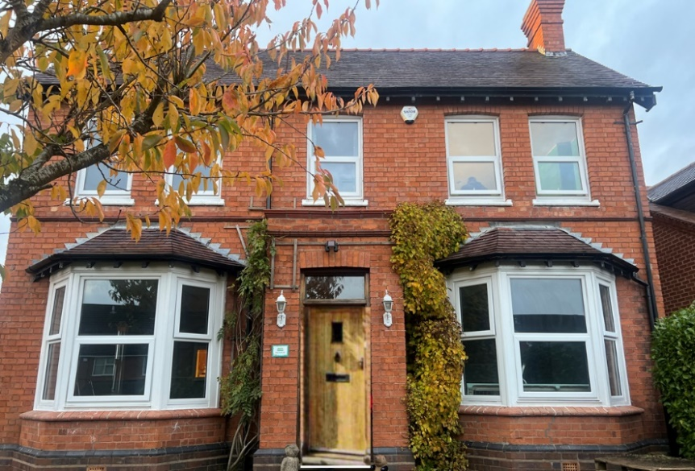
Red Brick House 3 months – 2 years

25 The Flats
Bromsgrove
B61-8LE
Contact number- 07445106703

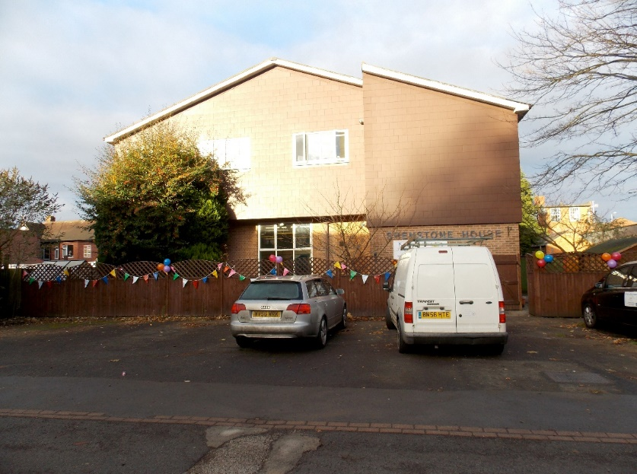

Shenstone House 2 years – school age

4 Shenstone Close
Bromsgrove
B60-1PG
Contact number- 07866935467

Our Mission Statement:

KIRSTY’S LITTLE TREASURES WILL PROVIDE HIGH QUALITY, ENJOYABLE, CARING AND STIMULATING CHILDCARE, WITH THE AIM TO GET THE BEST OUT OF CHILDREN BY UNLOCKING THEIR POTENTIALS.

KIRSTY’S LITTLE TREASURES WILL MAKE A POSITIVE DIFFERENCE WITHIN A CHILD’S LIFE

About

Kirsty’s Little Treasures is dedicated in providing high quality, enjoyable, caring and stimulating childcare, which is affordable and flexible. Our aim is to get the best out of the children that we work with by unlocking their potentials and allowing the children to explore and experiment building upon their interests and current achievements.

Ofsted say: “The nursery environment is inviting and very well organised. Children confidently enter the nursery and are happy to engage with staff and their peers. They are keen to investigate and explore their surroundings.”

Our setting is an ideal layout; enabling us to provide all that we desire for the children. It includes 3 outside areas, soft playroom, and a large kitchen; as well as 5 age-appropriate rooms for the children to explore within. The rooms are divided into 4 separate age ranges organised as follows:

Starfish, Octopus’ & Turtles:

An under 2's facility with separate areas for sleep, play and mealtimes which will facilitate up to a maximum of 21 children with 7 staff members.

Dolphins:

A 2-3's facility with separate areas for messy play and active learning, which will facilitate a maximum of 24 children with 6 staff members.

Parrots:

A 3-4's facility with separate areas covering all the EYFS requirements preparing children for pre-school. Parrots will facilitate a maximum of 16 children with 2 staff members.

Pre-School:

A 4-5's facility for school leavers, also with separate areas covering all the EYFS requirements, giving them the best possible transition into school. Pre-school will facilitate a maximum of 24 children with 3 staff members.

We also have:

- Fully equipped children's ablutions both upstairs and down.
- Blossom Education Parent App – this allows us to update you throughout the day on your child’s progress. This includes nappy changes, what they have eaten and also allows us to send observations which include pictures of them playing!
- A themed soft play area. The children love using the soft playroom for a general jump around, parachute games, exercise classes, races, balancing and dancing; plus, lots more.
- 3 outside areas; 2 complete with soft, safe flooring to enable the younger children to play and explore. We also have a sensory garden, dummy tree, outdoor role play area, planting areas, plus lots more.
- A learning room attached to Preschool to allow a space for focused learning or a sensory space for children who may have special educational needs or a space for any child just to have a rest!
- CCTV in all rooms and outside areas.
- We have an on-site kitchen which is ran by our own Kitchen Co Ordinator.

Each room within the setting has been carefully thought about in order to create an environment suitable for each individual age group. The resources and activities within each room have been carefully selected to reflect the age and stage of development of the children that will be using them.
The Under 2’s unit is designed to feel comfy and homely, creating a calm and sensorial experience. As the children move through the nursery there is a gradual change to more of a classroom feel, in the aim of preparing the children for their transition to school.

Safeguarding and Child Protection- It is our responsibility to create a culture and ethos within our setting that demonstrates a commitment to keeping children safe. To this end we must act upon any concerns that we may have and refer this to outside agencies where and when needed.

Ratios and Information

Under 2’s Unit (0-2 years) 1:3 ratio

Our under 2’s have 2 dedicated, spacious areas; these areas are organised dependent upon stages of development; non movers and crawlers (octopus’) and walkers (turtles). Each area contains different resources, furniture, and activities. The under 2’s unit has a dedicated sleep room containing 5 cots, low level tables and highchairs to support social interactions and also contains a self-contained kitchen. There is no set routine within the under 2’s unit and most of the children are on different routines; these are communicated during a child’s in depth settling in session between a parent/carer and the Under 2’s Co Ordinator.

Ofsted say: “Children progress well from their unique starting points in learning. They develop all of the skills they need for their future learning and starting school. Children develop good communication and language and literacy skills. Babies babble and use simple words to express their delight when playing with sensory objects. Toddlers enjoy singing and story sessions.”

Starfish is for our littlest Treasures and is based on a nurturing environment. Strong relationships are key to this age as well as a safe and secure environment.

Octopus’ is low level based, the staff spend much of their time on the floor with the children playing and interacting. All of octopus’ resources are accessible and allow the children to lead their learning and select what they would like to use.

Turtles is a little more structured as the children are now a little older, they have their own role play area and are now starting to use the table more for both feeding times and activities.

All the children in the under 2’s unit have the opportunity to take part in a range of different activities to include painting, shaving foam, drawing, role play, music, physical activities, sensory play, sand, water, cardboard boxes, outside play plus lots more. The 3 Prime Areas of the Early Years Foundation Stage (EYFS) are focused upon within the under 2’s unit, these are Physical Development, Personal, Social and Emotional Development and Communication & Language Development. The other 4 areas are still considered and supported but are not the focus of our daily routine.

The under 2’s unit have access to the outdoor areas at the front and side of the nursery.

Each area of the under 2’s unit has their own cosy area, whereby the children can go for some ‘quiet time’ these areas contain teddies and books and allow the children to escape and have a rest whenever they feel the need to do so.

The staff in the Under 2’s Unit have all attended specialised Baby Training and are all Paediatric First Aid Trained.

Ofsted say: “Partnerships with parents are strong. Staff regularly invite parents into the nursery. They encourage parents to contribute their knowledge of children, which staff use to inform planning. Parents speak highly of the staff team and are happy with the experiences provided at the nursery.”
Dolphins (2-3 years) 1:4 ratio

Our Dolphin’s classroom is a little more structured and organised and contains specific areas to support the EYFS Curriculum. Such as a messy area, creative area, construction area, role play area, drawing table, book corner and nappy area.
The children within Dolphins tend to now be on a similar routine and do things together at the same time. At this age children love to explore and experiment and can have short concentration spans! They make full use of the outdoors, soft play & the quiet room, as well as a range of fun and enjoyable activities within the classroom. They have a daily together time, where their social development is really supported and encouraged. Dolphins are now introduced to the 4 other areas of the EYFS which are Mathematics, Literacy, Understanding the World and Expressive Art & Design. There is also more of a focus on Toilet training within Dolphins and the staff are well versed in this and are always happy to advise and support parents and carers.

Parrots (3-4 years) 1:8 ratio

Our Parrots classroom is again more structured and organised as the aim is to prepare the children for Pre-School. The routine of the classroom still includes lots of fun and enjoyable activities and the children can still lead their own learning and make their own decisions. We now use the 7 areas of the EYFS to more effect to help plan for each child and promote development on an individual basis; the classroom again is divided into different areas as above in Dolphins. Parrots take part in daily together times where they take it in turns to speak and listen, with a different focus and agenda each day; they experience Phonics and Letters and Sounds, explore pencil skills, letters and numbers, and become more aware of difference and diversity.

Pre-School (4-5 years) 1:8 ratio

Our Pre-School classroom is once again more structured and organised and is a step up from Parrots as the aim is to support the children’s transition into school. The routine of the classroom is similar to Parrots and still includes all the fun and enjoyable activities, the children can still lead their own learning and make their own decisions but there now tends to be more adult led activities in preparation for school. We now consistently use the 7 areas of the EYFS to plan for each child and promote development on an individual basis; the classroom again is divided into different areas as with Parrots. Pre-School also take part in daily together times where they take it in turns to speak and listen, and they discuss daily starting school and how this will happen.

Ofsted say: “The key-person system is well established. Staff know children well. They obtain comprehensive details about children's routines and preferences when they start at the nursery. This means they have a thorough understanding of children's individual needs and interests. Children are content and settled.”

Recruitment & Staffing

At present there are 28 staff working at Kirsty’s Little Treasures. Kyle & Kirsty are the Managing Directors and Kirsty oversees the daily running of the nursery. Craig is the Nursery Manager and Emma is the assistant manager and HR lead at Shenstone. Charlotte B is Nursery Manager and Sarah is the assistant manager at Redbrick. All staff are Paediatric First Aid Trained and have all completed Safeguarding Training. Staff have also completed a range of different training courses and continue to do so, e.g., Behaviour Management, Special Educational Needs, Food Hygiene etc. Staff hold a variety of Level 2 and 3 qualifications in Early Years and Childcare.

Potential staff are given an interview and a trial shift before a position is offered, written references are obtained, a clear DBS check is needed, and all new staff are placed on a 12 week probationary period; during this period they will be given 4 weekly reviews to discuss their progress and any areas for development.

Ofsted say: “Self-evaluation is effective. Managers use a range of tools to evaluate the quality of provision. They regularly seek the views of children, staff and parents. They create and implement an action plan. This helps them to maintain at least good standards.”
Most staff members tend to be based in the same room/unit each day; this provides consistency to the children and parents/carers. Each staff member has their own key children and will be known as a ‘Key Person’ to them; this again promotes consistency and security within the setting.

Ofsted say: “Staff support children's physical development well. They encourage their small- and large-muscle skills. Babies enjoy turning pages of books and making marks with chalk. Toddlers delight as they empty and fill containers and prepare their own snacks. Preschool children learn to balance, negotiate space, and move their bodies in different ways.”
Catering

We aim to provide healthy, nutritional, and enjoyable meals for the children, we fully support a balanced diet and believe that this is the way forward in supporting healthy lifestyles. For our main meal of the day we use ‘Cupcakes Catering’ they supply a hot lunch and dessert for the children. Cupcakes are an accredited company and have worked alongside the Children’s Food Trust to ensure that the meals provided are healthy and nutritional. Cupcakes have also been graded a level 5 in their Food Hygiene Rating from Environmental Health. We provide the children’s breakfast, snack, and tea and again all meals are monitored to ensure that they support a balanced diet. We provide the children with milk to drink throughout the day and promote the drinking of water too, we are always talking about what the children are eating and drinking and why this is good for them! We can cater for any special dietary requirements, allergies, and individual preferences that your child may have, this will be discussed during the settling in and transition process.

Mealtimes

Cupcakes will provide a jacket potato if there is a meal that you know your child will not eat; at KLT’s we do not tend to provide alternative foods if they do not eat their main meal. We have done this in the past and find that we then have a large group of children who refuse their hot meal and want an alternative. We like to promote the cupcakes meal and try to encourage the children to eat this; if preferred you can supply a packed lunch.
Please see the menus within the appendix for a full listing of meals provided.

Vouchers & Nursery Education Funding (NEF)

KLT’s accepts all childcare vouchers and we are registered with several companies; if we are not, we will register with them. Please ask for more details.

0-2-year-old funding - we accept children who are eligible to receive 0-2-year-old funding; however, places are limited, and flexibility of requirements may be difficult. 0-2-year-old funding will be accepted and offered at 15 hours term time only this can be spread across the week in either three 5-hour sessions or two 7.5-hour sessions. These hours can also be stretched all year round and taken as 10 hours per week. Children can attend more but these sessions will be paid for separately; also, any food will need to be supplied or purchased by the parents/ carers. An Additional Service Charge will be invoiced to cover the cost of resources, extra-curricular activities etc, this is £3 a session.

3-year-old funding - All 3-year olds are entitled to 15 hours funding from the term after their 3rd birthday, you will need to complete a form for this entitlement and again places and flexibility can sometimes be difficult. Some children are now also entitled to an additional 15 hours funding, we will provide information around this when necessary. Additional hours will be charged per month. Also, food must be purchased or provided separately. Funding hours can be spread/shared to the parent’s discretion but must be agreed by both parties. An Additional Service Charge will be invoiced to cover the cost of resources, extra-curricular activities etc, a full day will be £12, and half a day will be £7.

Ofsted

Kirsty’s Little Treasures is registered with the Office For Standards in Education (Ofsted) our Unique reference number is EY470602. Ofsted inspect and regulate settings in order to achieve excellence in the care of children and young people. We were inspected on the 17th June 2019 and we were graded a ‘Good’ our next inspection will be any time now. For a full copy of the inspection report please see the Appendix.

Learning & Development

Each child within the nursery is provided with a learning journey which captures their time spent with us at nursery. We use photographs, observations, examples of their work and home links to contribute to the children’s learning journeys. From each insert into the learning journey a next step is raised and placed onto the weekly planning, each child’s individual needs and future developments are then included each week to work on. We have a parent’s evening each term to discuss your child’s progress, but the staff are always available for you to talk to. Learning Journeys are populated electronically through Blossom Education, please see our website www.kirstyslittletreasures.com for more information and the link.

Ofsted say: “Safeguarding is effective. Managers and staff benefit from regular safeguarding training updates. This supports them to identify possible signs of abuse or neglect. They also know how to recognise that a child may be at risk of extreme ideas and views. They understand their responsibility to accurately record and swiftly report concerns. This helps to protect children from harm. Managers implement effective procedures to supervise all staff. For instance, all staff complete a thorough induction period. They meet regularly with managers to talk about any concerns they have, reflect on previous objectives, and set goals for the future. This means all staff have a secure understanding of their key roles and responsibilities. This has a particularly positive impact on the quality of care they provide. Managers regularly monitor children's progress to identify any gaps in development. They use additional funding well to help reduce these gaps. This results in all children making positive progress.”

Extra Curricular Activities
KLT’S likes to provide a wide range of activities and allow the children to explore in a range of different situations. We currently have 2 extra curricular activities that we fund for the children to participate within in. On a Tuesday morning we have a dance session with all ages 2-5, this is a practical dance class where the children experience a range of different physical activities and musical movements, the children really enjoy this class and get a lot from it. On a Thursday morning the Parrots and Preschool have a ‘Rugby Tots’ class; this is a fun, exciting rugby session which helps with the development of gross motor skills.

Sleep Restrictions
At KLT’s we recognise a parents/carers knowledge of their child with regard to sleep routines and will, where possible, work together to ensure each child’s individual sleep routines and well-being continues to be met. However, staff will not force a child to sleep or keep them awake against his or her will. They will also not usually wake children from their sleep, if a shorter sleep time is requested by a parent/carer then we will call their name and make some noise around them but will not physically wake them up. We strongly believe that babies and children should be allowed to wake up naturally and in their own time.
Staff will discuss any changes in sleep routines at the end of the day with parents/carers and share observations and information about children’s behaviour when they do not receive enough sleep.
Opening Hours
Kirsty’s Little Treasures is open from 7.30 am-6.00pm Monday-Friday, 51 weeks of the year. We will be closed on National Bank Holidays as well as Christmas Eve and New Years Eve.

Contact Information

For additional information please visit our website: www.kirstyslittletreasures.com

Email: kirstyslittletreasures@gmail.com

Link to our most recent Ofsted Inspection Report:

https://reports.ofsted.gov.uk/inspection-reports/find-inspection-report/provider/CARE/EY470602.

Shenstone Ofsted reference number is EY470602
Red Brick Ofsted reference number is 2765000

We are very happy to show you around our nursery and discuss your childcare needs in more detail, please contact us as above.


Registration Form

Child’s Name: ____________________________DOB or Due Date: _________________________
For office use only:
Address: ________________________________

________________________________

________________________________

________________________________
Will your child be………
All year Term time only

Standard hours Enhanced hours
________________________________

Contact Number: ______________________________

Email address_______________________________________________________________

Attendance Required:
Days: |  | Meals:
 |  | Breakfast | Lunch | Tea
Monday:
Am | Pm
Tuesday:
Am | Pm
Wednesday:
Am | Pm
Thursday:
Am | Pm
Friday:
Am | Pm

My/our child will start at Kirsty’s Little Treasures on: _________________________
With the completion and return of this registration form I/we enclose a non-refundable registration fee of £80.00.
Signed ________________________ Signed ___________________

Full Name ________________________ Full Name ____________________

Date ________________________ Date ___________________

Bank Details for Registration Fee: Sort code- 600405 Account number- 85184861

GDPR – Information will be retained in accordance with our GDPR policy and only used in relation to the provision of childcare within KLT’s

PAGE INTENTIONALLY LEFT BLANK


Price list, calculations, holidays & out of hours care

Price list:
Session | Times | Prices As of April 24 until 31st March 2025
Enhanced Full Day | 7:30am-6:00pm | £72.00
Enhanced Am session | 7:30am-12:30pm | £40.00
Enhanced Pm session | 1:00pm-6:00pm | £40.00
Standard Full Day | 8.00am-5.30pm | £63.00
Standard Am session | 8.00am-12.30pm | £36.00
Standard PM session | 1.00am-5.30pm | £36.00
Additional hour (per child, per hour) | Un-contracted hours | £10.00
Meals (breakfast, snack, lunch & tea plus liquid refreshments. | - | £6
Late collection charge (per child, for every hour after 6.00pm) | Un-contracted hours | £12.00
Registration fee | - | £80.00
Breakfast | 7:30- 9:00 | £1.00
Lunch | 11:45 | £2.75
Tea | 3:15 | £2.25
Additional Service Charge (ASC) for funded children only * (0-2 year olds) | - | £3 per session
ASC for 3+ year olds |  | Half day £7  Full day £12

* KLT’s offer 2 options with 30 hours funding; 30 hours term time only, or a 20-hour full time offer. Additional hours will be charged per month. Also, food must be purchased or provided separately. Funding hours can be spread/shared to the parent’s discretion but must be agreed by both parties. We also invoice an Additional Service Charge which is used to fund resources, extra curriculum activities etc.; for 0-2 year olds, this is £3.00 per session. For 3+ year olds, this will be £7 for half a day and £12 for a full day. Any child attending 15 hours or less across any form of funding will not be subject to the Additional Service Charge. Our Nursery Educational Free offer is to attend nursery for 15 funded hours or less per week.

Monthly fee calculation:
Nursery fees are calculated over 52 weeks.

Fees will be calculated as follows:
(amount of days attending per week) x £…… (price per day) x 52 (weeks) =……. (amount per year to year) ÷ 12 = £…….. (monthly fee to pay).

Holidays & Illness:
Please be aware that you pay for your child’s place within the nursery; as such monies will not be deducted for illness, holidays, Bank Holidays or general none attendance. KLT’s is closed Christmas Eve and remains closed until the first working day after New Years Day.

Extra charges for consideration:
Complimentary snacks will be provided as required, breakfast, lunch and dinner are available at £6.00 per day per child. We have a 2-week menu on rotation for your viewing. Alternatively, you may provide your own meals for your child.

